FOLKtalk | Issue 60  Summer 2019

Friends of Leckhampton Hill

& Charlton Kings Common

Conserving and improving the Hill for you
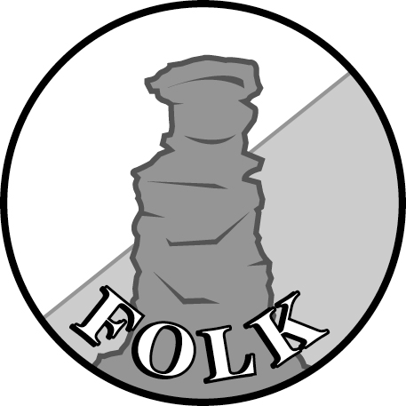
Inside this issue:
Bid submitted for major grant 2  70 years of Landscape Protection 4  90 years of Local Freedom 5  Unexpected Visitors 6  Epic migration: the cuckoo’s story 8  Butterfly Survey 2018: Part 2 10 | Charlton Kings Parish Council grant 14  Cuckoo spit 15  Word from Wayne 16  Mapping Project (Drone Survey) 19  Work Party Report 20  Guided Walks this Summer 23

NINETY YEARS OF FREEDOM
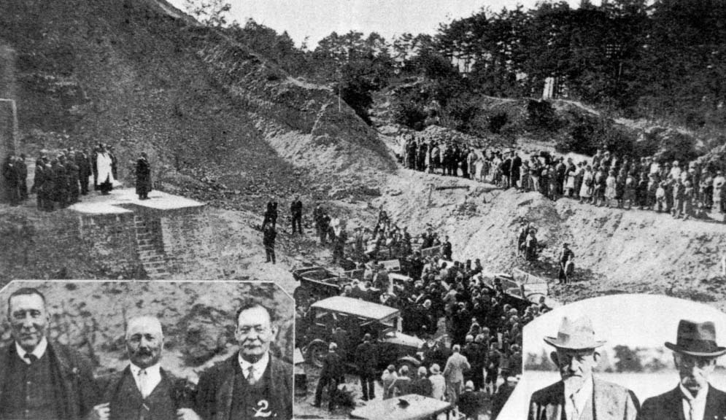
It is September 1929 and Cheltenham’s Mayor can be seen on the foundations of the dismantled limekilns, announcing that the Hill is now officially free for the public to enjoy. Ninety years on, this freedom is still a joy. See page 5
POWERING UP THE HILL AND THE COMMON
Restoring Cheltenham’s Escarpment Grasslands
John Harvey, Chairman
As I draft this note, the possibility of a major grant to help manage Cheltenham’s section of the Cotswold scarp is in the balance. The best outcome will be that a partnership of FOLK, the Borough Council and the Charlton Kings Parish Council will be awarded £196,000 from National Grid’s Landscape Enhancement Initiative (LEI) for management works, on the Common, on the Hill and on Ravensgate Common, between January 2020 and December 2023.
National Grid’s LEI is a very well-funded scheme aimed at alleviating the visual impact of major powerlines, such as that running approximately south to north just to the east of Seven Springs. If it is not possible to directly reduce a line’s impact, then works in corridors three kilometres either side of it can be funded if they give compensatory benefits in terms of landscape conservation or public benefit. All of the Common and most of the Hill are within the western corridor, as is the nearby Ravensgate Common which is managed by the Parish Council. This geographical link was independently recognised by FOLK and the Parish Council late in 2018 and the partnership was formed early in 2019. An initial bid submitted in February was accepted in principle. In April, many hours were devoted to developing more detailed proposals which are now being considered by National Grid.
The LEI’s emphasis on landscape and public benefit is not unexpected, but did mean that our first proposals had to be refocused to make less reference to the nature conservation values of the sites. In practice, nature will be one of the main beneficiaries, as most of the major works will benefit wildlife as well as views and public enjoyment. An example is the proposed removal of invading Gorse from much of the limestone grassland. This will restore both the vistas of open grassland so evident in photographs of the Common taken in 1968 and 1975 (see Images section of FOLK’s website) and the valuable grassland habitat.
Other projects that have been proposed include: the felling of trees that have grown up to hide views, as around the Devil’s Chimney; creating fire breaks in stands of old Gorse, which will hopefully limit the spread of accidental fires; the fencing of Cowslip Meadow to enable it to be grazed; the management of Veteran Trees along the boundary with the Golf Course; improvements to the Cotswold Way; continuing the rebuilding of the Cotswold Stone Wall near Hartley Lane; and the provision of new interpretation materials. Less impressive, but equally important, will be the production of a new Management Plan.
What sorts of impact might these projects have on the Common and the Hill and on their future management? More attractive and uninterrupted views linked to better access and improved interpretation are National Grid’s top targets. Delivering these should both enhance nature conservation interests and put the site on an entirely new footing for future management. For example, using contractors should bring the invasion of Gorse into grassland under control in three years, much more quickly than could be done by FOLK Work Parties. Then, the new grassland habitats created should require much less maintenance, freeing up Work Parties for jobs that may previously have been neglected. In addition some important issues, such as the care of Veteran Trees, will have been addressed for the first time for very many years. The scheme is therefore likely to be an unrepeatable opportunity to deliver a new era for the Common and the Hill.
The £196,000 hoped for from National Grid is not the only input to the scheme. The Partners have to contribute £64,000 of matching funds. The two Councils will contribute £20,000 in cash, with the remaining £44,000 being the cash value of work by volunteers, from both FOLK and from the Cotswold Wardens.
Editor’s Note
It is understood that an initial response might be available after a meeting of National Grid’s review panel in July, but firm acceptance might not be forthcoming until November. We will keep you posted about the progress of this exciting bid over the coming months.

SEVENTY YEARS OF LANDSCAPE PROTECTION . . . .
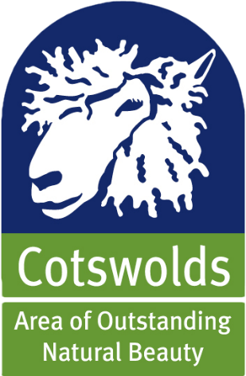
The Act of Parliament which paved the way for two great structures in our nation’s protection of its rural landscape – National Parks and Areas of Outstanding Natural Beauty - was passed seventy years ago this year. After the Second World War, Parliament was keen both to protect our most beautiful landscape areas and to re-connect people with the countryside.
So as part of the post-war re-construction programme the government brought forward a bill which was subsequently passed as the National Parks and Access to the Countryside Act (1949). This put in place statutory measures:
- to protect certain naturally beautiful landscapes
- to enable people to benefit from quiet enjoyment of the countryside and
- to have regard for the interests of those who live and work there.
National Parks are large areas of land protected because of their beautiful countryside, wildlife and cultural heritage. People live and work in the National Parks and the farms, villages and towns are protected along with the landscape and wildlife. The first National Parks were designated in 1951: The Peak District, The Lake District, Snowdonia and Dartmoor. There are currently thirteen national parks across England and Wales.
Areas of Outstanding Natural Beauty are areas of land which share many of the same qualities as national parks, but are generally smaller and contain less “wild” landscape. Despite being smaller as individual units they still cover approximately 15% of England. There are currently thirty four AONBs in England and four in Wales. The AONB on the Gower was the first to be designated (in 1956) and The Cotswolds AONB – the largest in the UK at 787 square miles - was designated ten years later.

. . . . and NINETY YEARS OF LOCAL FREEDOM
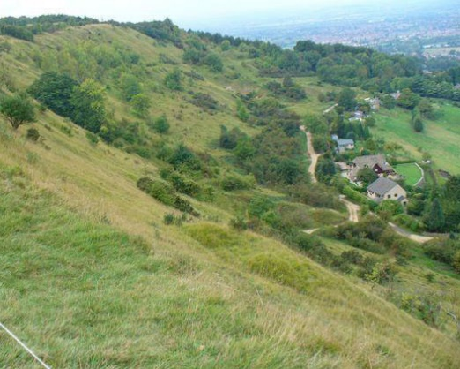
In 1927 the then Cheltenham Town Council bought 400 acres of land including Leckhampton Hill and, in an official ceremony in September 1929, the hill was declared open to the public. This followed a bitter dispute between the people of Cheltenham and the owner of the hill.
After centuries of enjoying the freedom to walk on Leckhampton Hill, the public found itself barred from entry by the new landowner, Henry Dale, at the end of the nineteenth century. For thirty years, between 1897 and 1927, Dale went to extensive trouble to keep the public off his land – erecting fences and even building tramway cottage on a site best fitted to block the historic footpath up the hill. All this, of course, led to rising public anger and eventually sparked the Leckhampton Riots, after which eight campaigners (“The Stalwarts”) were jailed.
Thanks to their perseverance, however, we can now celebrate ninety years of the right to roam on Leckhampton Hill – and what a glorious privilege it is to have this magnificent hill on our doorstep. Indeed it is the very special nature of the hill as a place to enjoy as well as a special environment to preserve which shapes the work of FOLK and explains why we labour not only to care for the geology, archaeology and ecology of the Hill, but also to enhance and promote its recreational use.
BAT WALK
In September, we have organised a free Bat Walk up on Leckhampton Hill, led by the Gloucestershire Bat Group.
See item in The Word from Wayne on page 17 for details.

UNEXPECTED VISITORS

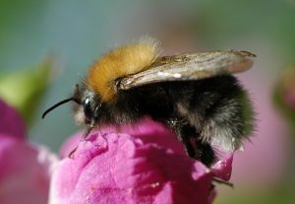
Many a garden boasts a nestbox of one kind or another and there is something very special about playing host to a pair of garden birds – watching on as they build their nest, incubate their eggs and feed their voraciously hungry offspring before eventually seeing the young fledge. However, this abundance of housing options for garden birds inevitably leaves some boxes unoccupied – and offers a tempting opportunity for a different kind of lodger: tree bumblebees (Bombus hypnorum).
This is a very distinctive species which has a completely ginger-brown thorax and a black abdomen with a white tail. Particularly in males, the first and sometimes second abdominal segments can also be brown, but there are always entirely black segments between the brown and the tail.
Tree Bumblebee
Even though this species only arrived in the UK in 2001, its population here has burgeoned and it is now one of our seven most widespread and abundant bees. They are seen in a wide range of habitats across the UK, but appear to favour open woodland and suburban gardens. It is believed that the tree bumblebees’ habit of building nests in holes in trees and in bird boxes and other manmade environments lies at the heart of both its nesting choices and its successful proliferation. It can now be found well into Scotland, and is widespread and abundant across England and Wales.
Typically a colony will occupy a nest site for two to three months and most will move on by the end of July. In general, tree bumblebees in gardens are amenable guests and pose no great threat to their human hosts. Apart from all the usual traffic in and out of the nest, it is also fascinating on a hot day to see a ring of males lining the round entrance to the nest box, facing outwards and beating their wings to cool the interior. Understandably, however, these bees are highly protective of their nest and once the site is fully established, the male drones are often seen on “surveillance” duties, forming a cloud of up to twenty bees around the entrance. This in itself is no problem, especially if the nestbox is well above head height, attached to a solid wall and sits well away from too much human activity. However, tree bumblebees are very sensitive to vibration and this in turn may provoke actively defensive behaviour. These males do not have a sting, but will certainly let humans who annoy them know that they are not welcome, especially May, June and July.

A Personal Postscript
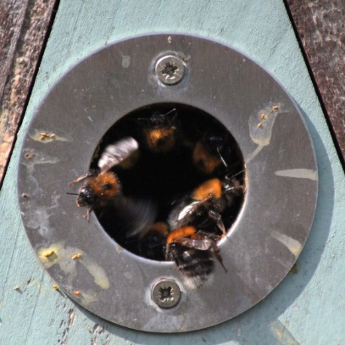
A colony took over the great tit box in our back garden early in April and once we had identified them as tree bumblebees we decided to take a chance that we and the bees could peacefully co-exist. At first all seemed to go well, but unfortunately a combination of circumstances worked against us. Our nest box is on the side of the garden shed, at head height, very close to the shed door and also right beside the seating area of our patio. As the weeks rolled on we inevitably became busier gardeners, frequently opening and closing the shed door and collecting and returning garden tools, including a motor mower which, when in operation, runs very close to the nest box. However gently we tried to do these things, the bees became increasingly agitated by all this unavoidable activity. My wife and I had both been mobbed by the male drones, even when we were a few yards away from the nest, and although these males do not sting I can vouch for their ability to give a very painful bite. The fact that we regularly look after our four-year-old grandson and would hate him to be at risk was the final straw. So we reluctantly decided that the bees had to go. We contacted a specialist company who carefully removed the nest box and re-sited it in suitable and secluded woodland. It was not a cheap option, but we were very keen to do no harm to the bees while at the same time making our garden safe again.
Tree Bumblebees fanning the nestbox
Martin Wood, Newsletter Editor

EPIC MIGRATION
One Cuckoo’s Story
For generations, the sound of the first cuckoo has lifted our hearts after the rigours of winter and, along with the return of other popular migrant birds, has raised our hopes that summer really is on the way. Sadly, the general feeling that fewer and fewer cuckoos are heard each Spring is borne out by some pretty depressing statistics. Put simply, in the last twenty-five years the number of cuckoos reaching the UK has plummeted by more than half.
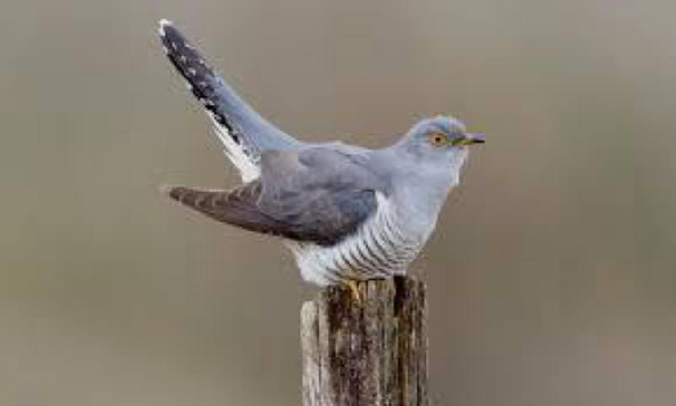
The causes of this decline have not yet properly been understood, though a number of theories have been emerging. So, in 2011, the British Trust for Ornithology (BTO) began an ambitious project to try to increase our detailed understanding of the cuckoos’ annual migratory journeys and the possible impact of the many different challenges they face along the way.
Crucial to the research was the development of new 5G tags to track the birds’ movements. These “Platform Transmitter Terminals” (PTTs) are small enough to allow birds as light as 100g to be tracked and include a solar panel which enables the device to be re-charged. Five cuckoos were tagged in 2011 and the data gained from the tags is beginning to reveal the extraordinary scale of their migration.
The account of one cuckoo’s annual migration in 2017-18 paints a picture of surprising endurance and many difficulties. This male, dubbed “Selbourne” by the researchers, set off on his southward migration in mid-June (before some of our other summer migrants had even arrived). He was found in France, west of Le Mans, on 16 June and then near Salamanca in Spain on 24 June where he spent time “re-fuelling”. Even this was a surprise as it was believed that most cuckoos headed south via an eastern route, crossing Italy or The Balkans, not Spain. So it is now known that substantial numbers of cuckoos also use this western route favoured by Selbourne.
Next stop Algeria, with Selbourne crossing the Sahara Desert in late July before reaching the central African state of Burkina Faso a few days later. Up to now, all five countries he had visited lie on the Greenwich Meridian, but Selbourne then flew south east, settling in his main wintering ground in Gabon by mid-October. By this time he had been on the move, flying alone and at night, for around four months and had covered approximately 5,000 miles.
After about three and a half months in Gabon, Selbourne started his journey back to the UK. He was first tracked to the Ivory Coast in early February 2018, where he had a feeding stopover before crossing the Sahara and landing in Morocco in late March. By mid-April he was back in the New Forest. In the ten months since he departed in the previous June, Selbourne had covered anything between 9,000 and 12,000 miles and settled temporarily in seven different countries before returning to his familiar breeding territory near Beaulieu, Hampshire.
So why might numbers of cuckoos in the UK be falling?
While the simple scale and duration of the cuckoos’ migratory journey seems daunting enough, other factors are having a marked effect on the numbers reaching our shores. While mortality rates appear similar along much of each of the routes, the number of Cuckoos which perish on the western route are higher than those who take the eastern route via Italy, Libya and Chad. There is a strong correlation between these mortality figures and trends in the UK breeding population.
Despite the obvious ecological barrier presented by the Sahara, it was actually in Europe itself that the study revealed the highest mortality rates for Cuckoos migrating by the western route. This suggests that the conditions at European “stop-over” sites are having a significant negative impact on the cuckoos’ survival. Factors here include the droughts and wildfires experienced in recent years in Spain, combined with sharp declines in Cuckoos’ main food source on the breeding grounds (the caterpillars of large moths) which were also particularly severe in areas in which birds migrating on the west route were tagged. Further research will be needed to understand more fully these emerging conclusions about the threats to our Cuckoo population.

BUTTERFLY SURVEY 2018 – Part 2
Further analysis of the survey records
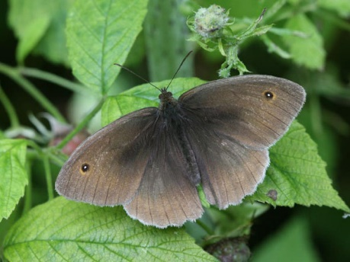
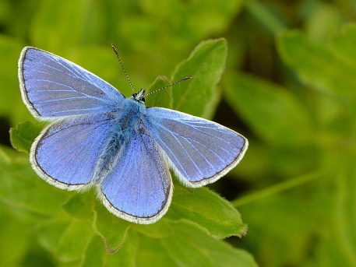
Introduction Since the initial report on the 2018 butterfly survey, published in the Spring edition of FOLKtalk, more detailed analysis of the results has been completed. This second report by Serena Meredith our Butterfly Survey Co-ordinator, illustrates what has been observed across different habitats on the Hill by highlighting data on two species: the Common Blue and the Meadow Brown.
Meadow Brown
Common Blue
A full version of this report, with all the tables and charts, will shortly be posted on the FOLK website.
SURVEY REPORT – PART 2
In this report, comparisons of results have been made between habitat types, adjusting for differences in the number of surveys undertaken in the season and therefore the distance covered in each type. However no account has been made to restrict the calculation further to just the flight period.
Habitat type For a species such as Common Blue, the greatest numbers were recorded in areas with the shorter turf necessary for the survival of its larval food plant, Bird's-foot Trefoil. Meadow Brown on the other hand likes a sward that is quite tall and lush, and this is reflected in its habitat preferences. These differences are clearly seen in the charts opposite.

This detailed comparison illustrates the need to maintain as wide a variety of habitat types as possible, with varying turf heights, in order to accommodate the needs of the maximum number of species: not just butterflies but other invertebrates as well, because as a group they underpin the whole ecological system upon which all the vertebrates rely.
Management regimes By far the greatest proportion of the site is grazed extensively by the herd of Dexter cattle for much of the year, and this is reflected in the relative distances surveyed in 2019 when comparing the management regimes. Just over half of the distances surveyed were in areas of extensive grazing, approximately one quarter was divided between areas subject to occasional grazing and rotational mowing, while the remaining quarter was mainly on land with no active management.
Interestingly, though, simple comparisons with habitat types do not provide the full picture. Logic would suggest that the area of extensive grazing would have a shorter sward during the butterfly season and therefore hold a higher proportion of the populations prefering such conditions.
However, by doing a similar comparison against management regimes, this does not hold true. Despite 26% of Common Blues being counted in the extensive grazing area, when adjusted for distance surveyed, this reduces to just 8%.

Interestingly, similar trends are also seen when comparing the charts for Meadow Brown, despite its different requirements.
What is the likely reason? The most obvious explanation is the lack of nectar due to the effects of grazing and the reduction of larval food plant material at least for Common Blue, though Meadow Brown would not be so affected by the latter. The areas where there is rotational mowing and ad hoc management to prevent a build up of thatch and to encourage the conditions for a herb rich sward see their proportion of populations increase. Because of the limited nature of these two managements regimes, populations can survive and flourish in adjacent undisturbed areas from which they can re-establish themselves in their preferred habitat. Where there is no management, it is possible that conditions are deteriorating, at least for short turf species, whilst benefitting the longer turf ones.
As for the 2019 season with all its variations so far in weather conditions, numbers have been slow to rise, but several sightings have been made of Duke of Burgundy, some of which are in areas in which they have not been recorded before. So I am hopeful of a good butterfly year ahead.
If you would like to help with the 2019 survey, please get in touch.
Serena Meredith
Butterfly Survey Co-ordinator
Contact details: Phone 01242 524138,
email: gmeredith308@btinternet.com
May 2019

CORRECTION In the previous edition of FOLKtalk, a photograph was inserted by the editor (not by the author) to illustrate the appearance of the Common Blue butterfly. Unfortunately, unbeknown to the editor, the photograph turned out to be one of an Adonis Blue, which, in any case, was not recorded on the Hill in 2018. I am very grateful to Serena Meredith (Butterfly Survey Co-ordinator) both for pointing out this editorial error and also in providing the editor with a much more reliable on-line source of images for future editions. Editor

THANK YOU CHARLTON KINGS PARISH COUNCIL
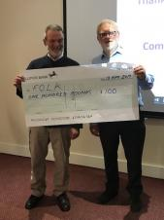
Earlier in the year FOLK was delighted to receive a grant of £100 from Charlton Kings Parish Council. This money was put to immediate use with the purchase of circular saw blades for one of our brush cutters.
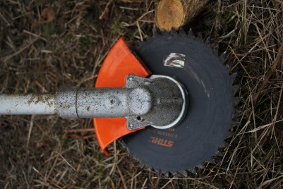
During the spring, this modification to the brush cutter made a big difference to the rate at which – in some locations – large, old stands of gorse can be cleared. In one morning alone, the saw blade enabled a single volunteer to clear as much gorse as it would normally take a small team to achieve by hand. So our Work Party volunteers are indeed grateful for this generous grant!

FOLK QUIZ NIGHT
A lively crowd of FOLK members and other green spaces “Friends of” groups came together on the evening of Friday 10 May for a second FOLK Quiz Night at The Wheatsheaf. More than forty competitors, in teams of six with suitably witty names, tackled a wide range of questions posed by experienced quizzers Gill and Mark Douglas. As ever, after much head-scratching and gasps of frustration as long-known facts refused to come to mind, the winners and losers were announced.
The committee is grateful to Pete Niblett for organising this event and to the landlord of the Wheatsheaf, both for the use of the room and for the excellent buffet.
Congratulations to all involved!
CUCKOO SPIT: HARMLESS OR HAZARDOUS?
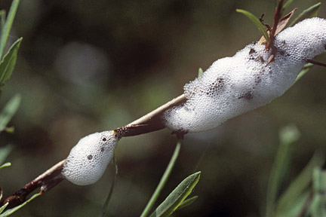
At this time of year we are all familiar with the sight of small, frothy deposits appearing on the stems of wild and garden plants. This is generally referred to as “cuckoo spit”, though the only connection with the bird itself is that both the cuckoo spit and the cuckoos appear at around the same time of year: May-June. Each bubbly blob is actually a protective bubble created by the young nymph of a Froghopper. There are several varieties of Froghopper, though among the more frequently seen is the Common Meadow Spittlebug (Philaenus spumarius). The nymph feeds on the plant sap (xylem), until it reaches its adult stage and leaves behind both its host plant and the dwindling remains of the cuckoo spit.
Cuckoo spit
So far, so harmless – up to now. Mature Froghoppers do little or no harm to plants, but in their nymph stage their sap-sucking activity can spread the very damaging plant disease Xylella which has been wiping out olive crops across southern Europe. Fortunately Xylella has not yet spread to the UK, but plant diseases have a tendency to continue to migrate often with drastic consequences. This is where we can all help. Scientists at the Biological Records Centre (BRC) are keen to learn more about the prevalence and location of cuckoo spit and the plants on which it appears. This research will help Britain’s plant scientists to be better prepared if Xylella does spread to our shores. If you want to help by reporting your sightings, go to
brc.ac.uk/irecord/xylem-feeding-insects
The whole thing takes about five minutes. After entering your name and contact details, you say what plant you saw the cuckoo spit on. The next section begins by asking which species of froghopper you saw. Unless you have good knowledge, this is a bit off-putting, but if you enter Philaenus spumarius (as your best guess) the next box allows you to say how certain you are of this. As you progress through you will have a simple option to say that what you actually saw was the cuckoo spit not the froghopper itself.
THE WORD FROM WAYNE
Wayne Sedgwick, Senior Ranger, Cheltenham Borough Council
The Dexter herd is thriving. The fourteen calves born last September have been weaned and have re-joined the mature cows, with the entire herd now taken off their winter pasture on Hopkins Field and released to graze up on the 34 hectares (84 acres) of open land on Charlton Kings Common. Dexters are the smallest European breed of cattle – about one third the size of a typical Friesian cow – and have many traits which make them ideal for our site. As an old mountain breed they do well on steep slopes and poor pasture, they make excellent mothers and they produce both good milk and high quality beef. Importantly too, for a site with open public access, they are docile and generally very comfortable with people. When busy on work parties we often find the cattle approaching – grazing nearby or just passing through.
Please remember that, however docile Dexters may be, all cattle are protective of their calves. So, especially at this time of year, people using the Hill are advised to give the Dexters just a little more space, to walk calmly and quietly, and not to attempt to pass between a cow and her calf.
Dog owners should of course keep their pets under control. By all means keep your dog on a lead if you feel that is best, but in the extremely rare event of the cattle becoming threatening do not hang on to your dog; it is far safer to let the dog run away (They run a lot faster than cows!) and then you may either stand still or just keep steadily walking – this makes it far less likely that the cattle will see you as a threat.
Back from the Brink. Regular readers of FOLKtalk will be familiar with this nationwide, multi-agency project to conserve those species of flora and fauna judged to be most at risk. In our area of the Cotswolds, the targeted species are Adders and the Duke of Burgundy Butterfly. Adders are basically shy and much prefer to keep away from places frequently used by humans, but they do need good, safe sites where they can shelter, feed and bask in the sunshine. So in two secluded sections of Leckhampton Hill – one near the Hill Fort and the other not far from the disused Salterley Quarry – “Adder Mats” were installed in March. These small sheets of black corrugated material provide an ideal site for Adders to bask or hide and recent surveys show that their presence is already having a positive effect. The local Adder population also received a boost a few years ago when populations of both common lizards and slow worms were moved from sites being developed for housing to carefully selected spaces on Leckhampton Hill. Both of these species are sources of food for Adders. Good numbers of Adders have been observed on the some of the mats, but we are keen to discourage members of the public from lifting the mats to see what lies below. So small signs will be installed at some sites during the summer to explain the mats and encourage people not to touch them. In the meantime, the Adders can continue to thrive with a little help from their new mats.
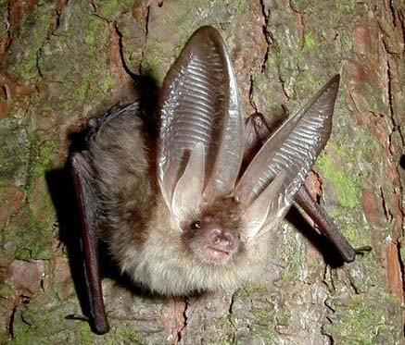
Bat Walk. There is a healthy population of bats on the Hill, including lesser horseshoe bats, long-eared bats, noctule bats and common pipistrelle. To help people gain a better understanding of this bat population and its habitat, the Gloucestershire Bat Group has planned a Bat Walk.
This walk will take place on Friday 13th September, starting at 7pm where we will meet in the car park known as Brownstones, at the very top of Leckhampton Hill. The walk will be led by experts from the Gloucestershire Bat Group and it is hoped that bat activity may be seen from about 8pm onwards. It is expected that the walk will end sometime between 9:00 and 9:30. There is no charge for taking part, but we will be taking a collection at the end of the walk. It is not necessary to book places. Just turn up and enjoy the walk.
Long-eared bat

Industrial Archaeology. The evidence of Leckhampton Hill’s industrial history is scattered across the site, but only careful management prevents it from further deteriorating or becoming swallowed up by scrub. So to add another dimension to everyone’s enjoyment of the Hill, FOLK is starting to develop a circular walk focusing on the local industrial archaeology and providing those who visit the Hill with more information about this aspect of its history. More news of this will follow in future editions of FOLKtalk.
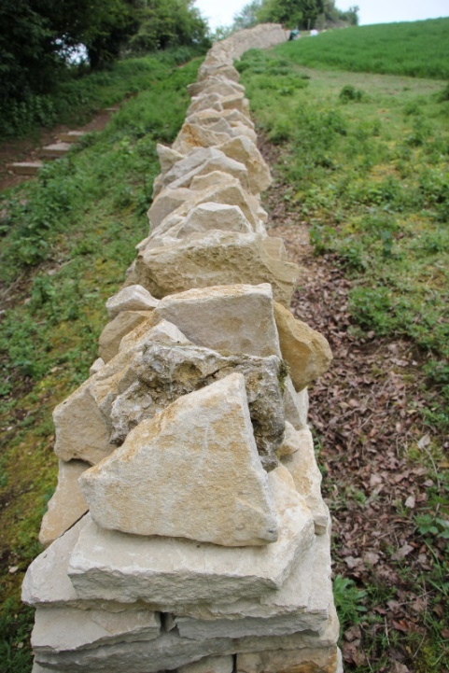
Drystone Wall. Work continues on the mammoth task of building a drystone wall from Hartley Lane to the area near the Hill Fort. This work is being undertaken by volunteers from the Cotswold Wardens as part of their celebratory programme of 50th Anniversary projects. The wall begins very near to Hartley Lane itself, and quite close to the small rough layby on the left as you ascend the lane. It is worth a visit at the moment just to see the stages involved in building these marvellously resilient boundary structures.
Tramper route. In previous editions of the newsletter we have described the plan to improve access to the Hill for people using rough terrain mobility scooters, generally called “trampers”. This involves a short trial scheme in which a series of up to seven gates along an otherwise accessible footpath may be left open to avoid the challenge of repeatedly opening and closing gates from a seated position.
The trial is underway and one observation made so far is that while the opening of such a long stretch of footpath is great for the trampers it does enable other users, e.g., mountain bikers, to build up considerable speed. Currently, thought is being given to balancing the needs of differing sets of users and some modification of the trial plan may be introduced so that everyone can benefit. More news will follow in future editions of FOLKtalk.

DRONE SURVEY UPDATE
The fruits of the drone survey completed in April 2018 are certainly beginning to appear. The survey gives us an accurate picture of the whole of Leckhampton Hill in very great detail. It has been possible to use the image data to construct accurate maps that help with specifying where work needs to be done on the hill including the planning of firebreaks, attention to poor quality scrub and other invasive saplings, and repairs or improvements to footpaths and fencing. It has been over 15 years since a classification of the various habitats on the hill was made and this can now be brought up to date as many areas on the hill have greatly changed in character during that time.

One undoubted success to emerge from the survey is the excellent work of applying the drone data to our ongoing task of managing the gorse. Images from the survey, combined with our detailed local knowledge, help us better to decide and map the most important work which needs to be done and also how labour-intensive each area of gorse clearance is likely to be. This, in turn, helps us to organise more effectively the week-by-week plans for the work parties and ensure that we use our volunteer resources to the best effect.

Other recent projects have allowed us to document the positions of the newly placed Adder mats which help with understanding how these shy reptiles live on the hill. More information about this may be found in the separate article on Back from the Brink in The Word from Wayne (p. 16).

We are hugely indebted to committee member Ken Brennan for his tirelessly diligent and very technical work in processing and interpeting the data from the drone survey.

FOLK WORK PARTY REPORT
Since the end of January we spent a few more work parties on our winter cutting activities and then turned our attention to a lot of tidying up and repair work.
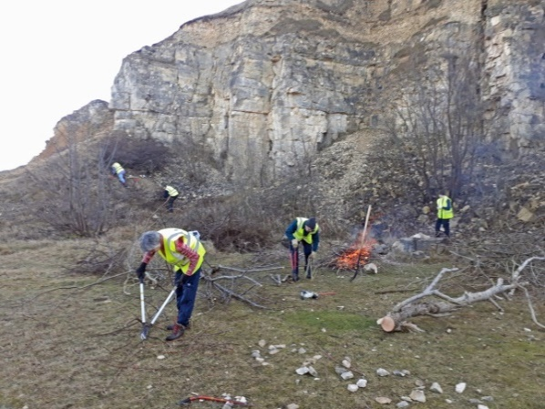
As a change from chopping down gorse, which we had done quite a lot of previously, we spent one work party in Deadman’s Quarry (not very far from the Devil’s Chimney) which we had not worked on for quite some years. Here we removed the likes of ash saplings and cotoneaster which were taking over.
Deadman's Quarry - clearing ash and cotoneaster
We next worked on the track that runs down from the top of the Hill to the Woodland Walk which runs under the Devil’s Chimney. We had spent some time here a few years ago clearing ash saplings, but we hadn’t finished it all; so we went back to have another go.
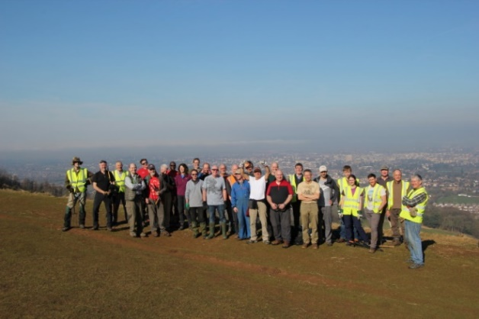
On the Sunday work party in February we were joined by 21 local paragliders, making 32 of us in all, and we worked on clearing gorse and other obstructions from the areas on top of Charlton Kings Common where they fly from. As you can imagine, with that number of workers we managed to get a lot done. Thank you paragliders, do come again sometime!
FOLK Volunteers and Paragliders at the end of a long morning's work
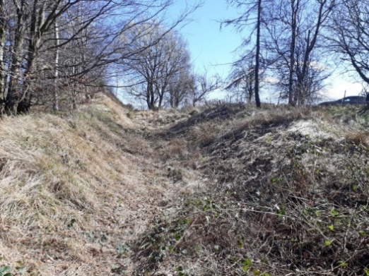
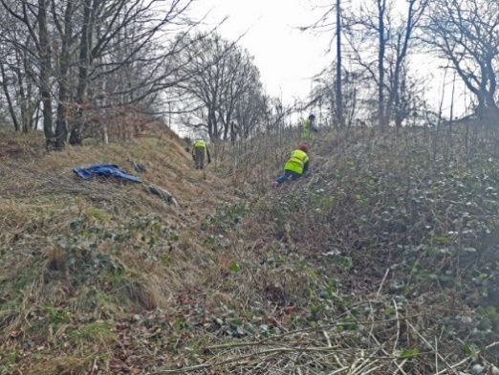
We next spent time up on the ‘sidings’ on the top of Leckhampton Hill. This area is one of the interesting industrial archaeological features on the site and formed part of the various tracks and tramways that were used in the quarrying days. They tend to get overgrown and to disappear from view and so we cut away the ash saplings that were taking over. Quite a few passers-by stopped to talk to us (which is always nice) and they were surprised to learn what the features were.
Clearing Ash from "The Sidings" - Before . . .
. . . and After

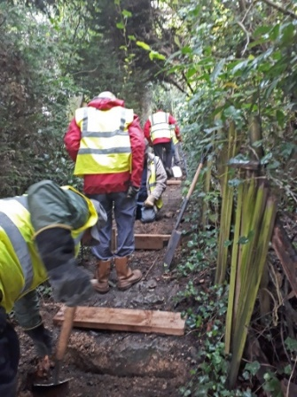
Our next task certainly wasn’t planned. Somebody, who is definitely not a friend of Leckhampton Hill, set fire to three patches of gorse one Monday which required the fire brigade to turn out. These fires left rather a mess alongside the Cotswold Way and so we decided to do a bit of cosmetic work and remove that damaged patch of gorse. It took us two work party sessions!
Repairing steps
To finish off this period we did various odd jobs. This included burning a number of piles of gorse and ash cuttings that we had left around the site from earlier work parties and repairing steps and footpaths.
Finally, we did a trial job. We cut a number of drainage channels across the Standard Gauge Incline which goes up from Bridge Car Park on Daisy Bank Road. The idea of this is to try and direct some of the water off the side of the incline rather than it all running down to the bottom and forming its usual muddy pool. We will check how effective this trial is when it next rains hard and, if it works, we will think about doing something a bit more permanent.
As you can see, there is always plenty to do. So, if you, or anyone else you know, would like to join in, please do join any of our FOLK work parties. We are a friendly, mixed group of male and female volunteers. You can work at your own pace and take a break as and when you wish. We meet at 9.30am at Tramway Cottage Car Park, Daisy Bank Road, and are on the hill for approximately 3 hours. Tools are provided by FOLK. For your own safety we ask you to wear stout footwear and bring tough gardening gloves. We have three FOLK work parties a month. Dates for the next 6 months are printed below.
For further information you can contact Geoff on 01242 244165 or you can look at the ‘Work Party’ page on our website (www.leckhamptonhill.org.uk) or send an email to folk.workparty@gmail.com.

Work party dates to November 2019
June 2019 | Thursday 13th | Tuesday 18th | Sunday 23rd
July 2019 | Thursday 11th | Tuesday 16th | Sunday 28th
August 2019 | Thursday 8th | Tuesday 20th | Sunday 25th
September 2019 | Thursday 12th | Tuesday 17th | Sunday 22nd
October 2019 | Thursday 10th | Tuesday 15th | Sunday 22nd
November 2019 | Thursday 14th | Tuesday 19th | Sunday 24th

GUIDED WALKS THIS SUMMER
The Cotswold Voluntary Wardens will be leading a walk on Leckhampton Hill on the afternoon of 22nd June, the day after the summer solstice. Everyone is welcome - just turn up and join in, but please be aware: no dogs (unless guide dogs or hearing dogs) and no unaccompanied children. The walk is free, but the Cotswold Wardens – who do a wide range of amazing work on the Hill and Charlton Kings Common - are all volunteers and so donations to support their work will be most welcome at the end of the walk.
Arrangements
Please meet at the main door of St Mary’s Church in Charlton Kings at 1.30pm and make yourself known to the leaders. The route will go through Old Bafford to Sandy Lane via the golf course. Then there is a steady climb to Daisybank Road and upwards onto the scarp and the Cotswold Way at Hartley Hill. After enjoying views from the topograph, the route will descend below the Devil’s Chimney to the old limeworks and then all the way down to Southfield Manor and back through Bafford to the church. This is about 5 miles and the aim is to complete it in 3 hours.
The Wardens grade this walk as “strenuous” because of the long climbs out of Charlton Kings onto the hills. They advise stout footwear, maybe walking poles and hats/water.

The Wardens are also leading a linked walk in the morning of about 5 miles, starting from the same church at 10am. This will climb up past Vineyards Farm onto Ravensgate Hill and then descend through Lineover Wood. From the reservoir there will be another long climb up the Cotswold Way to Colgate Farm and then a return down to Chase Avenue and back to the church. Again everyone is welcome to just turn up and join in.
Details of these walks – and indeed all walks run by the Cotswold Wardens across the whole of the Cotswolds – are available at www.cotswoldsaonb.org.uk/visiting-and-exploring/guided-walks/.

ABOUT FOLK
FOLK is an organisation set up to work with landowners, to promote the conservation and management of the ecology, geology and archaeology of Leckhampton Hill and Charlton Kings Common. We support sustainable recreational and agricultural use of the land. We welcome new members to support and help us in this important work. If you wish to join (either as an individual or as a family) please contact any of the people listed below. There is currently no fee for membership.
If you have any comments on the Newsletter or would like to contribute an article to the next edition please contact Martin Wood on 01242 231230 or email to: martinwood360@gmail.com. Articles of around 500 words plus a photo at any time would be most welcome.
Why not have a look at what is new on the FOLK website http://www.leckhamptonhill.org.uk/ and look us up on Facebook Friends of Leckhampton Hill and Charlton Kings Common.
Contributions to the FOLK Website are always gratefully received.
Contact: webmaster.leckhamptonhill@gmail.com
Contact FOLK
John Harvey, Chairman: 01242 520053
Geoff Holt, Work Parties: 01242 244165
Malcolm Geddes, Treasurer: 01242 514602
Tony Duffin, Membership: 01242 522767
Martin Wood, Newsletter: 01242 231230
Find the Friends of Leckhampton Hill & Charlton Kings Common on www.leckhamptonhill.org.uk and on Facebook

The views expressed in the articles are those of the authors and do not necessarily reflect the views of FOLK or its Executive Committee.

