Your Councillors  Cllr Rob Williams (Chair)  Cllr Jessica Diamond  Cllr Christopher Bryant  Cllr Russell Grimshaw  Cllr Penny Hall  Cllr Clive Hodges  Cllr Ned Holt  Cllr Janet Honeywill  Cllr Joanna Hughes  Cllr John Hughes  Cllr Lynda Johnson  Cllr Pat Palmer  Cllr Felicity Parnham  Cllr Rob Reid | NEWSLETTER No.2  Parish Council Newsletter Newsletters are posted on Noticeboards within the Parish and made available on the Parish Council website. If you would like a hardcopy of the Newsletter, this can be collected free of charge from the Parish Office.  Parish Councillor vacancies There are currently three vacancies on the Parish Council. Being a Councillor is a varied and interesting role which allows residents to have a positive impact on their community. For more information see the Parish Council website or contact the Parish Office.  Exciting opportunity for an experienced Community Development Worker Charlton Kings Parish Council is seeking an experienced Community Development Worker on a part-time, contract basis from January 2020 to deliver the first phase of the CK Health Connections social prescribing project. The closing date for applications is 9.00 am on Monday, 21st October 2019. For further information about the role and how to apply see the Parish Council website or contact the Parish Office.  Community Open Meeting Our next Community Open meeting will take place from 7.30 pm on Wednesday, 23rd October at the Stanton Suite with refreshments from 7.00 pm. For this meeting, following the Borough Council’s recent declaration of a Climate Emergency, we have decided to focus on Climate Change and hope to draw on your enthusiasm, help, and ideas in moving things forward and potentially developing a Parish Council environmental group. At the last meeting, we discussed local issues such as flooding, traffic, green spaces, and recycling, and we hope next time to draw further on your interests, knowledge, experience and expertise to make our parish a leader in environmental sustainability. The Parish Council needs to accurately identify the small but important actions it can take itself, without disrupting its business, in order to be a legitimate voice for community.  FREE Community First Aid Course A free Community First Aid Course will be run by Gloucerstershire County Council at the Stanton Suite from 9.00 am to 1.00 pm on Saturday, 9th November 2019. All welcome. For more information contact the Parish Office.  Stalls available for Christmas Fayre Although it is only October, we are already making plans for our Christmas Fayre and light switch-on which will take place from 3.00 pm to 6.00 pm on Friday, 6th December. We hope to offer a range of Christmas gifts and crafts. If you are interested in having a stall at the Fayre, please contact the Parish Office.  Community Grant – Neighbourhood Watch Bicycle Security Marking The Parish Council runs a grant scheme to which local charities and community groups can apply. One of our most recent grants was to Neighbourhood Watch towards the very successful Bicycle Security Marking event that took place at East Gloucestershire Tennis Club on 21st September 2019. The combined total of bikes that have been security marked at this event and the previous event in June 2019 at Church Piece, is 277. For more information about our Community Grants, including criteria and how to apply, see the Parish Council website or contact the Parish Office. For more information about Bicycle Security Marking see www.BikeRegister.com  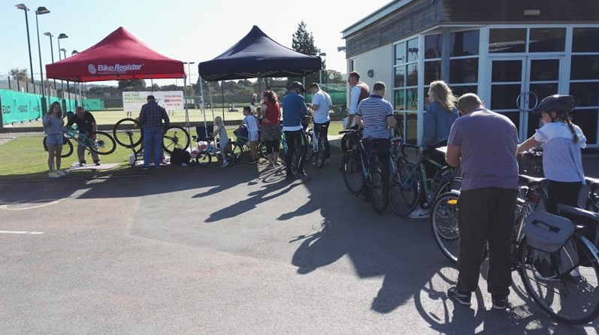  Allotment Awards evening Allotment holders and their guests gathered in the Stanton Hall on 16th September for the annual Awards Evening. This year again saw a very high standard across all the sites and the awards were presented by Chris Evans BEM of Dundry Nurseries. Congratulations to Neil Hyde who won the Ted Jarrett Memorial Rose Bowl for the best allotment in Charlton Kings. The Parish Council would like to thank the judges Chris Ryder, Dennis Sutton and Rob Rimell, as well as the Co-operative on Church Piece who donated refreshments for the event. To have a look at all the photos taken on the night please go to the gallery page of our website. If you are interested in becoming an allotment holder please contact the Parish Office.  Produced by Charlton Kings Parish Council – October 2019
    - October 2019
  Forthcoming events
  This month
  - Planning Committee meeting
  Monday, 7th October, 7.30 pm, Stanton Suite. All welcome.
  - Allotments Committee meeting
  Monday, 14th October, 7.00 pm, Conference Room at Stanton Suite. All welcome.
  - Planning Committee meeting
  Monday, 21st October, 7.30 pm, Stanton Suite. All welcome.
  - Community Open meeting
  Wednesday, 23rd October, 7.30 pm, Stanton Suite. All welcome. Refreshments from 7.00 pm.
  - Full Council meeting
  Monday, 28th October, 7.30 pm, Stanton Suite. All welcome.
  Further ahead
  - FREE Community First Aid Course
  Saturday, 9th November 2019, 9.00 am to 1.00 pm, Stanton Suite.
  - Christmas Fayre
  Friday, 6th December 2019, 3.00 pm to 6.00 pm at Church Piece
  Contact details
  Charlton Kings Parish Office,
  26 Church Street, Church Piece, Charlton Kings, Cheltenham, Gloucestershire, GL53 8AR
  01242 250087
  clerk@charltonkingsparishcouncil.gov.uk
  www.charltonkingsparishcouncil.gov.uk

